Food Label Chemistry Assignment
Many of the foods we eat have chemicals in them. Usually they are used to help preserve the food for a longer shelf life or make the food taste better. Sometimes they are harmless and sometimes harmful.
Directions: Start reading the labels of the foods in your house. When you find one with a chemical name provide me with the information below. You will have to research the rest of the information on the internet. I would like you to find 5 different foods with 5 different chemicals.
It might be better to use powerpoint and make slides or some other presentation program but you could do it on a word document too. Let me know if you have questions. I put a sample of a food item at my house and then the label. I even edited the phone picture and highlighted two different chemicals on the ingredient list … not bad for an old dawg! Ha!

Picture of the Food: 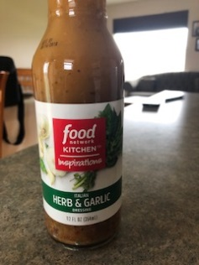
Picture of the label: 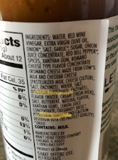
Food Name:
Chemical Name:
Chemical Formula:
Common Name of chemical:
Two other uses for the chemical:

